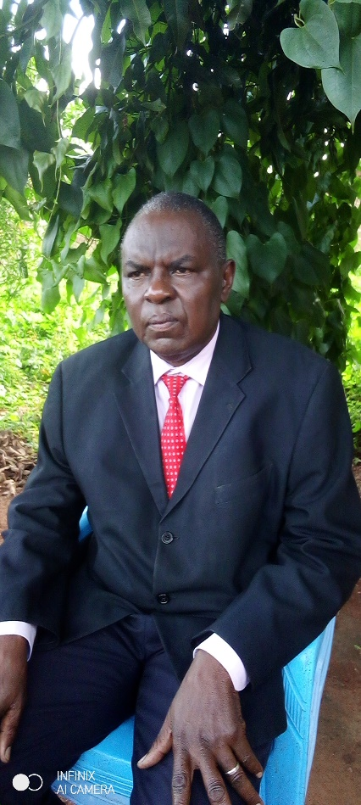**Select of these two photos of the Chairperson Board**

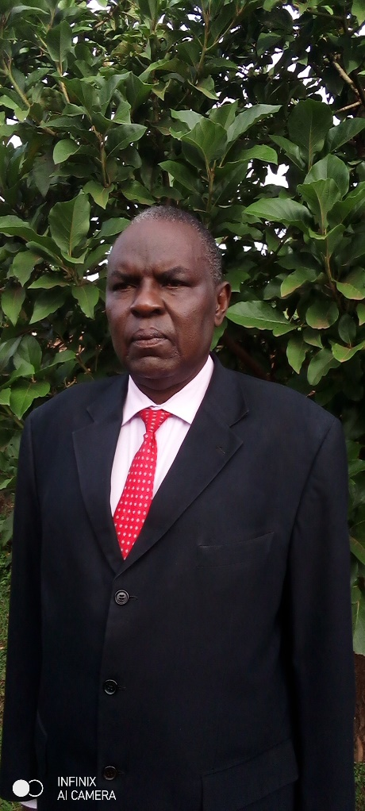

**Other photos you can use.**